Home

Websites that we’ve consulted:

https://www.edgetraining.co.za/
https://prospen.co.za/
https://www.kairostraining.com/

Below, all the courses Ndzalama Training applied for:

ETDPSETA DEVELOPED CURRICULUM STATEMENTS
OC-97154 - Occupational Certificate - Occupational Trainer
OC-101321 - Occupational Certificate - Training and Development Practitioner
OC- 97542 - Occupational Certificate - Early Childhood Development Practitioner - L4-131 credits

SP-220319 - Learning and Development Facilitator
SP-220320 - Assessment Practitioner
SP-220321 - Skills Development Facilitation Practitioner
SP-220322 - Workplace-based Practitioner Programme – Verified on 14 May 2026
SP-211001-Assistant Life Coach

SERVICES SETA DEVELOPED CURRICULUM STATEMENTS
SP-201201-Workplace Preparation
SP-211009-Workplace Essential Skills
SP-2110010-New Venture Creation

HWSETA DEVELOPED CURRICULUM STATEMENTS
OC-121929 Occupational Health and Safety Officer
OC-121930 Occupational Health and Safety Assistant
SP-230801-Basic Emergency First Aid Responder
SP-230802-Intermediate Emergency First Aid Responder
SP-230803-Advanced Emergency First Aid Responder

- Tag line (3-4 words) & Description (focus on Ndzalama’s experience)

Building Skills. Transforming Futures.
With over 20 years of experience, Ndzalama Training delivers accredited occupational qualifications, skills programmes and workplace training that equip individuals and organisations with practical, industry-relevant skills for long-term success.

Quick Buttons
📚 Browse Courses | 📅 Training Schedule | 📝 Enrol Now | 💼 Request Proposal

How Can We Help You?

I'm an Individual
Start your career, upskill or gain nationally recognised qualifications.
Buttons
- Browse Courses
- Upcoming Training
- Enrol Online

I'm a Business
Partner with us to develop your workforce through customised, accredited training solutions.
Buttons
- Corporate Solutions
- Request a Proposal
- Speak to a Consultant

- Quick Links: Browse Courses, Request Proposal, Training Schedule, Enrol Now
- How can we help you?
  - Individual Learner → browse courses, upcoming training schedule, enquire/enrolment form (online)
  - Business/Company → https://www.kairostraining.com/portal/company /
- Training Options: In person, In person & Virtual & On site (we come to you), Online
- Information Strip: 20+ years experience, learners competent+
- Calendar

- Contact Us: Visit our offices (Polokwane), Call or WhatsApp (Numbers), Online (Email & Website), Follow Us (social media)
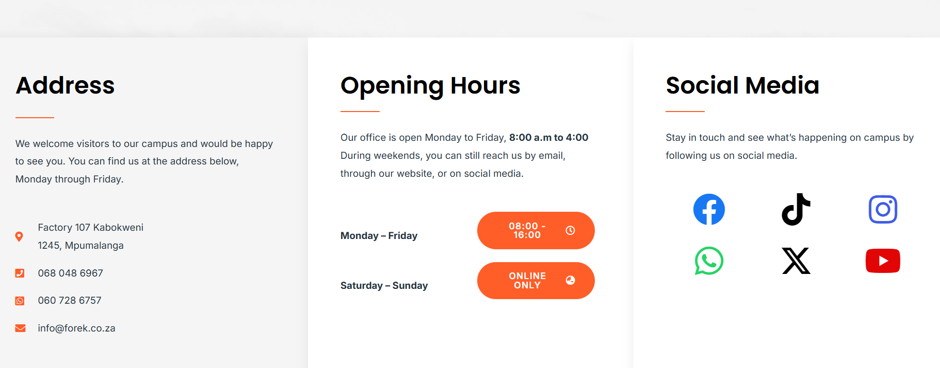
Course Categories
Hover & then this comes up, clear categorization with subheadings
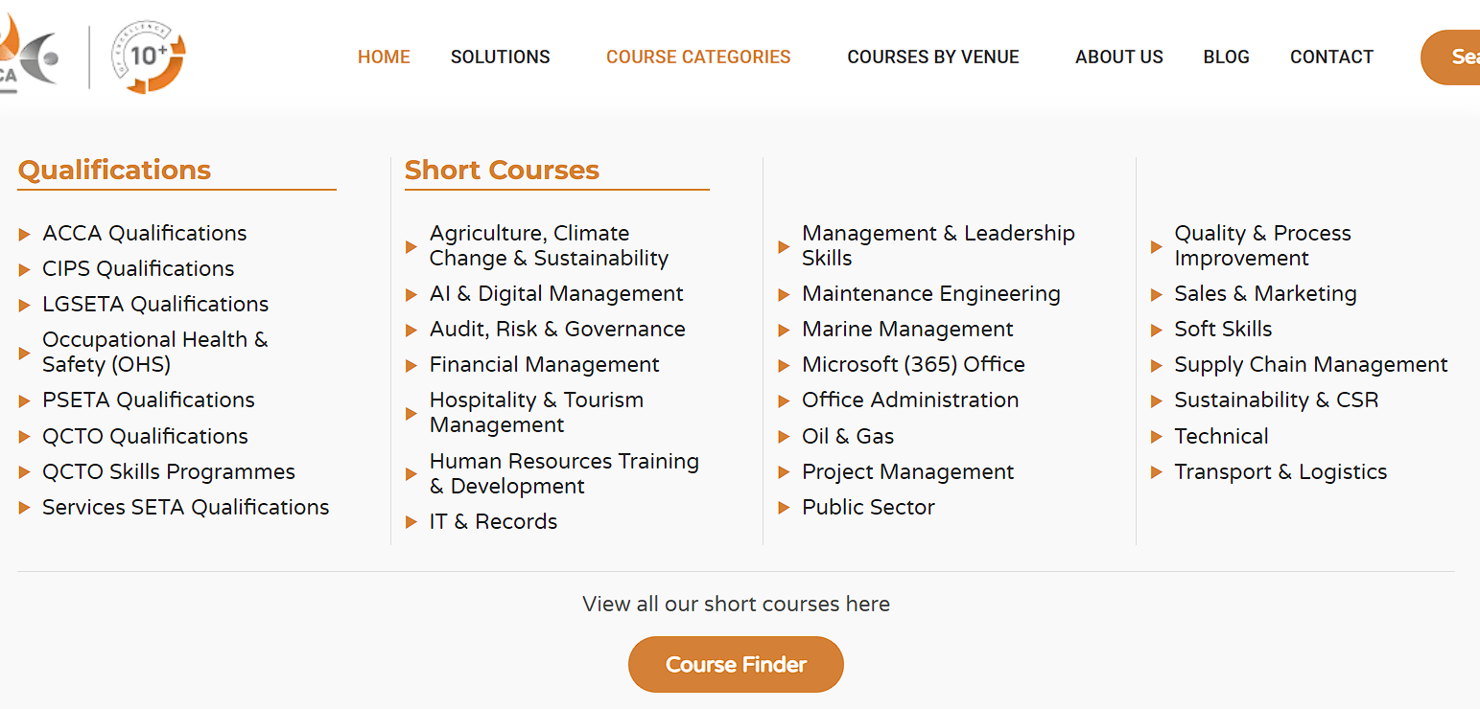

DROP DOWN
Occupational Certificates
- Education & Training
  - Occupational Trainer
  - Training and Development Practitioner
  - Early Childhood Development Practitioner
- Health & Safety
  - Occupational Health and Safety Officer
  - Occupational Health and Safety Assistant
QCTO Skills Programmes
- Learning & Development
  - Learning and Development Facilitator
  - Assessment Practitioner
  - Moderator
  - Skills Development Facilitation Practitioner
  - Workplace-based Practitioner Programme
  - Assistant Life Coach
- Business, Entrepreneurship & Employability
  - Workplace Preparation
  - Workplace Essential Skills
  - New Venture Creation
- First Aid
  - Basic Emergency First Aid Responder
  - Intermediate Emergency First Aid Responder
  - Advanced Emergency First Aid Responder

EXPLORE COURSES
Ndzalama offers a variety of courses
For each programme:
- Label e.g. “QCTO SKILLS PROGRAMME”
- Course Name
- Skills Programme Nr (SP-), NQF Level, X Credits
- Duration:
- Click Here For More Details


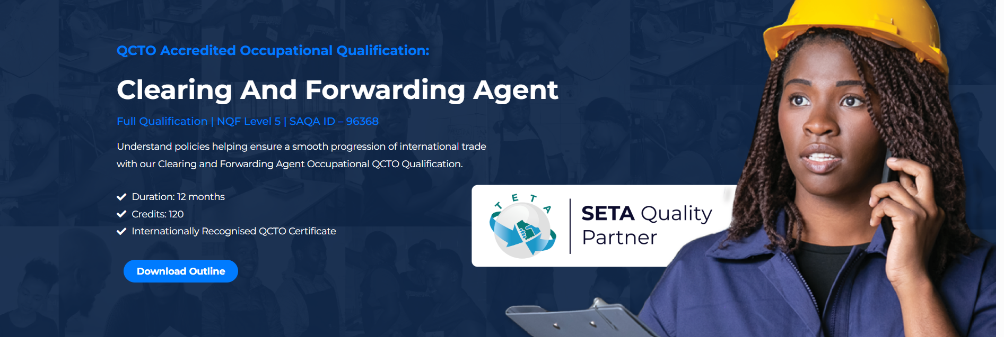
For each course:
- Course Introduction
- Course Duration
- Entry Requirements
- Learning Outcomes
- Who should attend?
- Assessments / Certification

Or
Details to know
Our Training Methodology
Who should do this occupational qualification
Requirements
Career Opportunities
Accreditation

- Course Content / Module Content
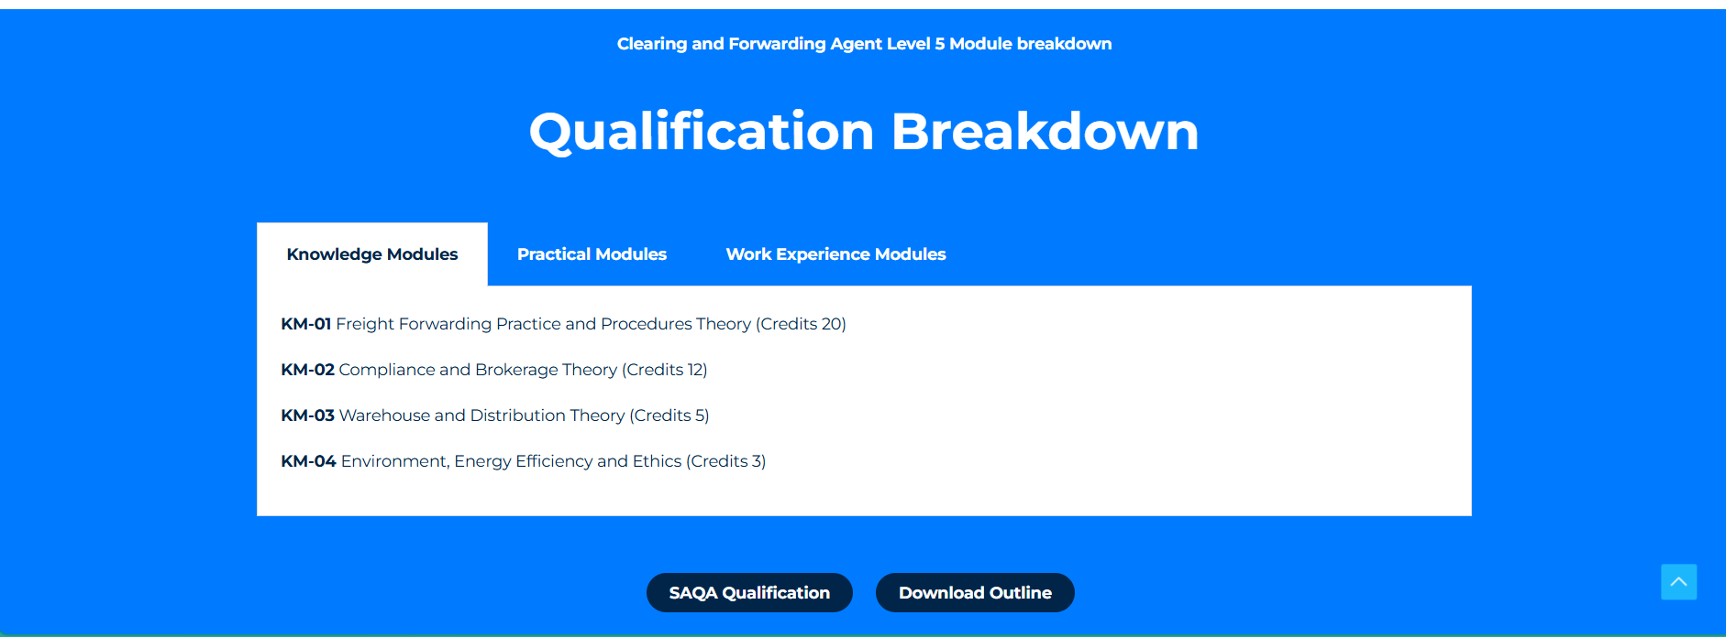
- Career Paths / Opportunities
- Download Brochure here
- Enquire / Enrol Button

Clearing And Forwarding Agent Qualification - Edge Training
SP-230802: Intermediate First Aid Responder | Prospen Africa

ELEVATE YOUR SKILLS WITH QCTO COURSES
As the South African training landscape evolves, Training Force remains at the forefront by offering a comprehensive suite of QCTO learnerships. These programmes are specifically designed to replace legacy qualifications, ensuring your team remains compliant and skilled in an ever-changing regulatory environment.
Our QCTO certificates ensure relevance, effectiveness, and quality, empowering your organisation and your employees to thrive. By choosing these occupational qualifications, you are investing in training that is designed by industry, for industry.

WHAT ARE THE ADVANTAGES OF A QCTO CERTIFICATE FOR YOU AS AN EMPLOYER?
Unlike older unit-standard-based training, QCTO certificates focus on “occupational qualifications.” This means the training is split into three distinct modules: knowledge, practical skills, and workplace experience. For you, the employer, this results in:
- Enhanced competency: Your employees don’t just “know” the theory; they have proven they can apply it in your specific workplace.
- Streamlined accreditation: The QCTO provides a single, high-standard framework that simplifies the verification of skills.
- Future-proofing: As legacy SETA qualifications expire, moving your team to QCTO-aligned programmes ensures your B-BBEE points and tax incentives remain secure.
QCTO LEARNERSHIPS THAT TRAINING FORCE CAN PROVIDE FOR YOUR TEAM?
Training Force offers a wide-ranging curriculum of QCTO learnerships across various professional sectors. We are constantly expanding our scope to include the latest occupational standards. We currently offer the following QCTO certificates, with more on the way:

About Us
Skills Development Training - SETA Accredited Learnerships
How old we are etc
Facilitators section
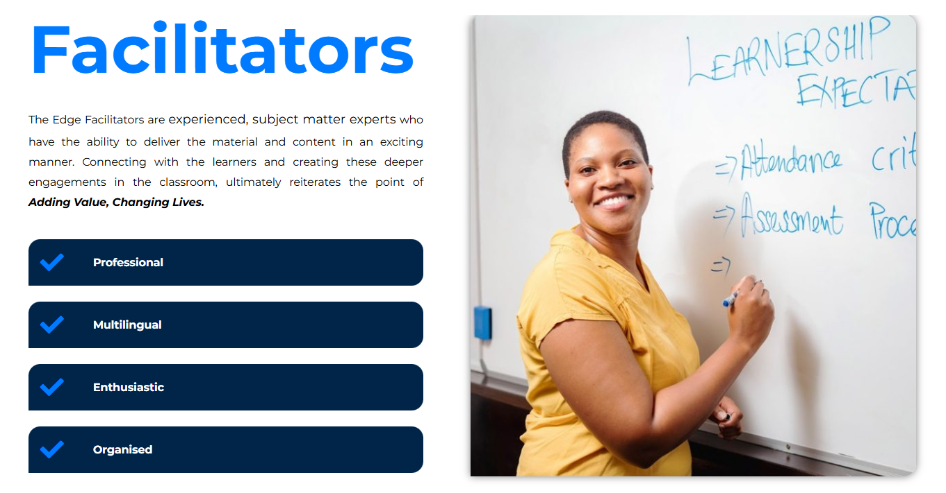
Vision & Values

Accredited Training Solutions
As a training provider, we are passionate about skills development training interventions, upskilling the future workforce of South Africa and finding the right solutions to maximise your B-BBEE points while minimising your spend.

Integrate: QCTO | SA's Shift Towards QCTO Qualifications - Edge Training

